# Problem: 1 | Searching Array

Write a program that initialize 15 numbers; then apply linear search to search an element from an array.

# Problem: 2 | Searching Array

Write a program that initialize 15 numbers; then apply binary search to search an element from an array.

# Problem: 3 | Searching Array

Input an integer containing only 0s and 1s (i.e., a “binary” integer) and store the elements of a number individually in an array and print its decimal equivalent. Use the modulus and division operators to pick off the “binary” number’s digits one at a time from right to left. Much as in the decimal number system, where the rightmost digit has a positional value of 1, the next digit left has a positional value of 10, then 100, then 1000, and so on, in the binary number system the rightmost digit has a positional value of 1, the next digit left has a positional value of 2, then 4, then 8, and so on. Thus, the decimal number 234 can be interpreted as 2 * 100 + 3 * 10 + 4 * 1. The decimal equivalent of binary 1101 is 1 * 1 + 0 * 2 + 1 * 4 + 1 * 8 or 1 + 0 + 4 + 8, or 13.

# Problem: 4 |

Jason, Samantha, Ravi, Sheila, and Ankit are preparing for an upcoming marathon. Each day of the week, they run a certain number of miles and write them into a notebook. At the end of the week, they would like to know the number of miles run each day, the total miles for the week, and average miles run each day. Write a program to help them analyze their data. Your program must contain parallel arrays: an array to store the names of the runners and a two-dimensional array of five rows and seven columns to store the number of miles run by each runner each day. Furthermore, your program must contain

1. Read and store the runners’ names
2. Initialize and store the numbers of miles run each day.
3. Find the total miles run by each runner and the average number of miles run each day.
4. Output the results: runnerName: milesDay1 milesDay2 milesDay3 milesDay4 milesDay5 milesDay6 milesDay7

# Problem: 5 | 2d Array

Write a program that can be used to assign seats for a commercial airplane. The airplane has 13 rows, with six seats in each row. Rows 1 and 2 are first class, rows 3 through 7 are business class, and rows 8 through 13 are economy class. Your program must prompt the user to enter the following information:

1. Ticket type (first class, business class, or economy class) 2. Desired seat

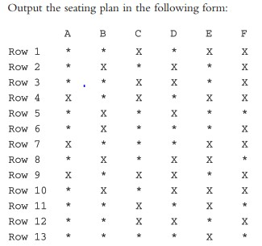

Here, * indicates that the seat is available; X indicates that the seat is occupied. Make this a menu-driven program; show the user’s choices and allow the user to make the appropriate choices.

Best of luck

**You are done with your exercise, submit on classroom at given time.**